**SALES Dataset & Queries Output**

**Dataset Code**:

drop table if exists goldusers_signup;

CREATE TABLE goldusers_signup(user_id integer,gold_signup_date date);

INSERT INTO goldusers_signup(user_id,gold_signup_date)

VALUES (1,'22-09-2017'),

(3,'21-04-2017');

drop table if exists users;

CREATE TABLE users(user_id integer,signup_date date);

INSERT INTO users(user_id,signup_date)

VALUES (1,'02-09-2014'),

(2,'15-01-2015'),

(3,'11-04-2014');

drop table if exists sales;

CREATE TABLE sales(user_id integer,created_date date,product_id integer);

INSERT INTO sales(user_id,created_date,product_id)

VALUES (1, '19-04-2017', 2),

(3,'18-12-2019', 1),

(2,'20-07-2020', 3),

(1,'23-10-2019', 2),

(1,'19-03-2018', 3),

(3,'20-12-2016', 2),

(1,'09-11-2016', 1),

(1,'20-05-2016', 3),

(2,'24-09-2017', 1),

(1,'11-03-2017', 2),

(1,'11-03-2016', 1),

(3,'10-11-2016', 1),

(3,'07-12-2017', 2),

(3,'15-12-2016', 2),

(2,'08-11-2017', 2),

(2,'10-09-2018', 3);

drop table if exists product;

CREATE TABLE product(product_id integer,product_name text,price integer);

INSERT INTO product(product_id,product_name,price)

VALUES

(1,'p1',980),

(2,'p2',870),

(3,'p3',330);

Note: - Since I am using PostgreSQL I have changed the date format from ‘MM-DD-YYYY’ to ‘DD-MM-YYYY’.

Here is the dataset:

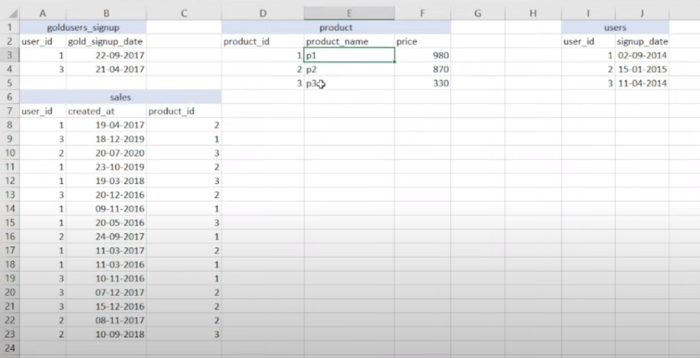

**Query 1**: **- What is the total amount each customer spent? Arrange in descending order of amount spent.**

Output:

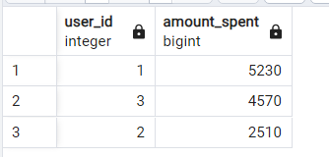

**Query 2: -** **How many days each customer visited the app?**

Output:

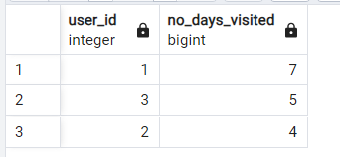

**Query 3: - What was the first product purchased by each customer?**

Output:

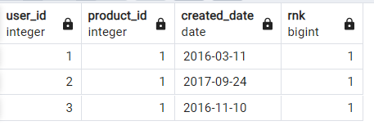

**Query 4: - What is the most purchased item & how many times it was purchased by all customers?**

Output:

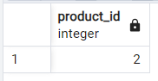--- > from where clause

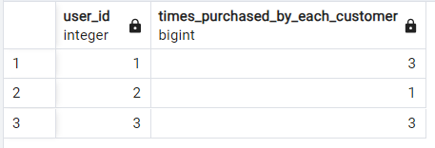

**Query 5: - Which product was the most popular for each customer?**

Output:

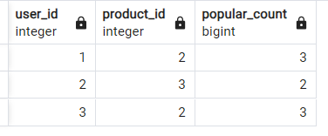

**Query 6: - Which product was first purchased by the customer after they became a member?**

Output:

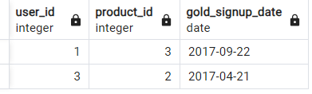

**Query 7: - Which item was purchased just before the customer became the member?**

Output:

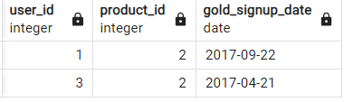

**Query 8: - What are the total orders and amount spent for each member before they became a member?**

Output:

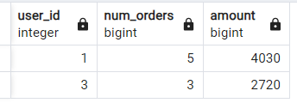

**Query 9: -** **Every product purchase generates points. p1->5rs=1pt, p2->10rs=5pt, p3->5rs=1pt. Calculate Points collected by each customer & for which products most pts have been given till now?**

Output:

1st part

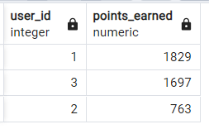

2nd part

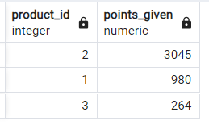

**Query 10: - In the first year after a customer joins gold program (including their joining date) irrespective of what the customer has purchased they earn 5 points for every 10rs spent. Who earned more 1 or 3 and what was their points earnings in the first year?**

Output:

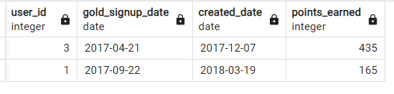

**Query 11: - Rank all the transactions of the customers.**

Output:

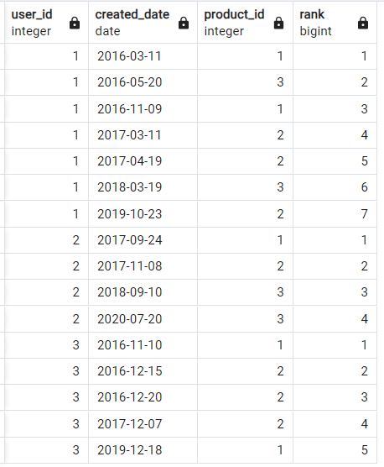

**Query 12: - Rank the transactions of gold plan members & for non-gold plan members rank as ‘0’** Output:

